**CHANDIGARH UNIVERSITY**

**UNIVERSITY INSTITUTE OF ENGINEERING**

**DEPARTMENT OF COMPUTER SCIENCE & ENGINEERING**



|  |  |
| --- | --- |
| **Submitted By:** Sahil Kaundal  **Submitted To:** Neeru Sharma | |
| **Subject Name** | Project Based Learning Java (Lab) |
| **Subject Code** | 20CSP-321 |
| **Branch** | Computer Science Engineering |
| **Semester** | 5th |

LAB INDEX

**NAME:** Sahil Kaundal **SUBJECT NAME:** PBLJ (Lab)

**UID:** 21BCS8197 **SUBJECT CODE:** 20CSP-321

**SECTION:** 20BCS_WM-616/A

|  |  |  |  |  |  |  |  |
| --- | --- | --- | --- | --- | --- | --- | --- |
| **Sr.No** | **Program** | **Date** | **Evaluation** | | | | **Sign** |
| **LW**  **(12)** | **VV**  **(10)** | **FW**  **(8)** | **Total**  **(30)** |
| 1. | Create an application to save the employee information using arrays. | 16/08/2022 |  |  |  |  |  |
| 2. | Design and implement a simple inventory control system for a small video rental store. | 20/08/2022 |  |  |  |  |  |
| 3. | Create a application to calculate interest for FDs, RDs based on certain conditions using inheritance. | 27/08/2022 |  |  |  |  |  |
| 4. | Create a program to set view of Keys from Java Hashtable. | 27/09/2022 |  |  |  |  |  |
| 5. | Create a program to show the usage of Sets of Collection interface. | 27/09/2022 |  |  |  |  |  |
| 6. | Write a Program to perform the basic operations like insert, delete, display and search in list. List contains String object items where these operations are to be performed. | 04/10/2022 |  |  |  |  |  |
| 7. | Create a menu based Java application with the following options.1.Add an Employee2.Display All3.Exit | 13/10/2022 |  |  |  |  |  |
| 8. | Create a palindrome creator application for making a longest possible palindrome out of given input string. | 10/11/2022 |  |  |  |  |  |

**Experiment 8**

**Student Name:** Sahil Kaundal **UID:** 21BCS8197

**Branch:** BE CSE (Lateral Entry) **Section/Group:** 616/A

**Semester:** 5th **Date of Performance:** 10/11/2022

**Subject Name:** PBLJ Lab **Subject Code:** 20CSP-321

1. **Aim/Overview of the practical:**

Create a palindrome creator application for making a longest possible palindrome out of given input string.

1. **Task to be done/ Which logistics used:**

Write the program to create an application to form a largest palindrome from given String.

1. **Apparatus / Simulator Used:**

* Eclipse IDE - (Java)
* NetBeans.
* JDK-8 or any.

1. **Programs/ Code:**

package unit2;

import java.util.HashMap;

import java.util.Map;

import java.util.Scanner;

public class Exp8 {

public static String longestPalindrome(String str) {

if (str == null || str.length() == 0) {

return str;

}

Map<Character, Integer> freq = new HashMap<>();

for (char ch: str.toCharArray()) {

freq.put(ch, freq.getOrDefault(ch, 0) + 1);

}

String mid_char = "";

StringBuilder left = new StringBuilder();

for (var entry: freq.entrySet()){

char ch = entry.getKey();

int count = entry.getValue();

if (count % 2 == 1) {

mid_char = String.valueOf(ch);

}

left.append(String.valueOf(ch).repeat(count / 2));

}

StringBuilder right = new StringBuilder(left).reverse();

return ("" + left + mid_char + right);

}

public static void main(String args[]) {

Scanner in = new Scanner(System.in);

System.out.println("Enter your String: ");

String str = in.next();

System.out.println("The longest palindrome is " + longestPalindrome(str));

in.close();

}

}

1. **Result/Output/Writing Summary:**

Here we have created the palindrome function to performed an operation on a String to create a largest possible palindrome.

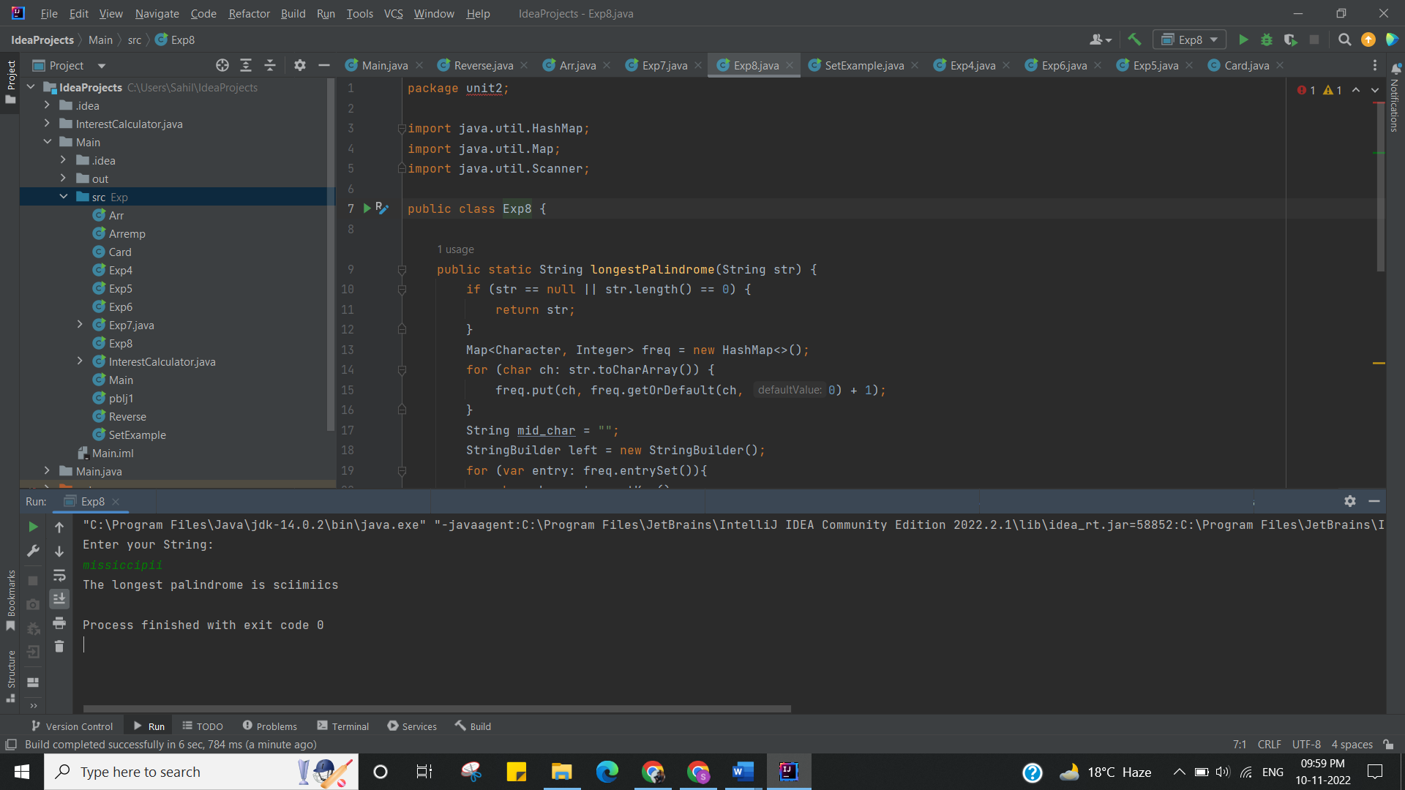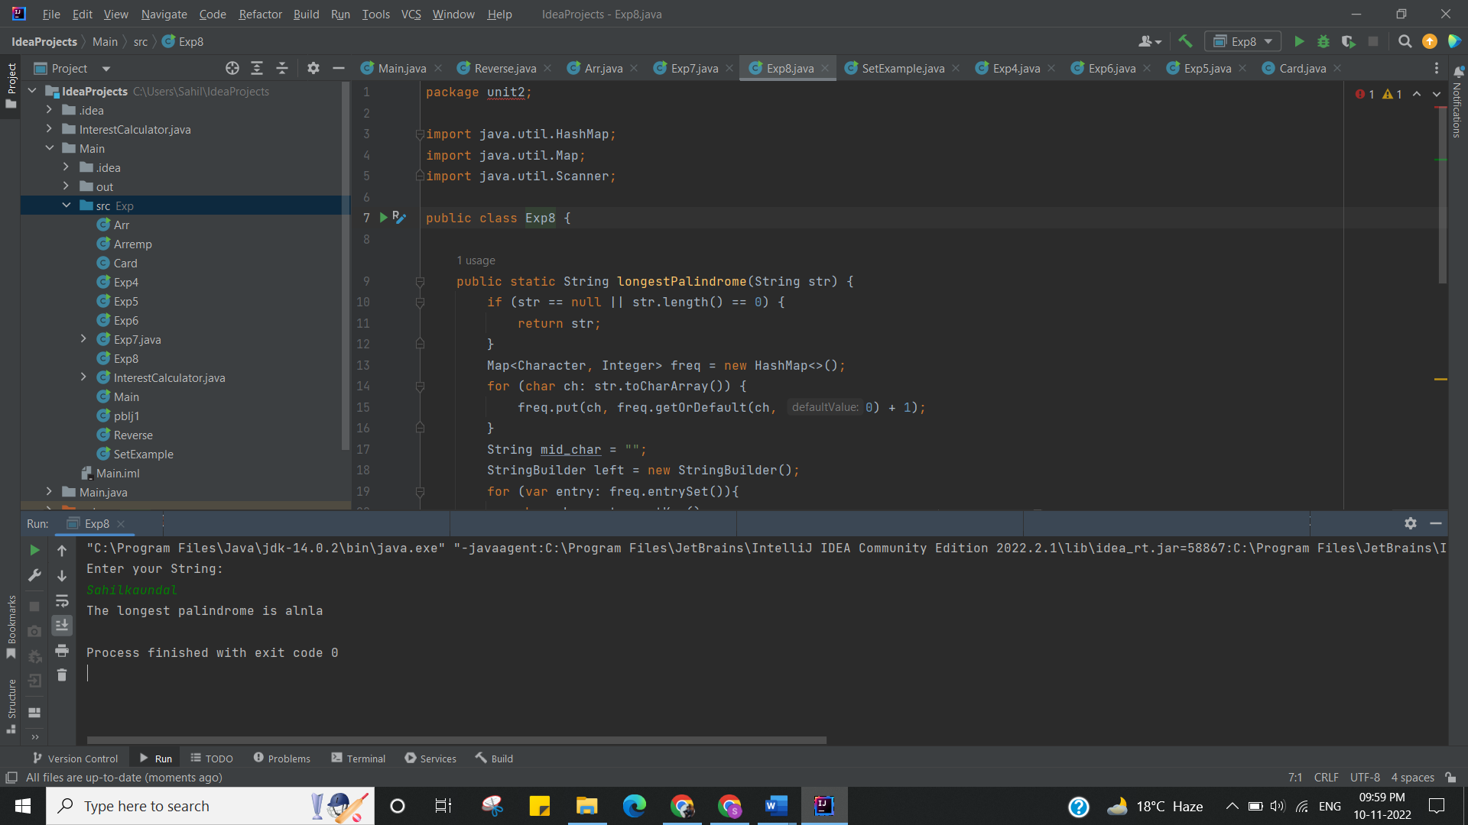

I have successfully done this program.

**Learning Outcomes (What I have learnt):**

* Learnt the concept of palindrome.
* Learnt the concept of StringBuilder ().
* Learnt the concept of HashMap ().
* Learnt the concept of StringBuilder Manipulation such as Reverse.
* Successfully executed the code and completed the Worksheet.

Evaluation Grid (To be created as per the SOP and Assessment guidelines by the faculty):

|  |  |  |  |
| --- | --- | --- | --- |
| Sr. No. | Parameters | Marks Obtained | Maximum Marks |
| 1. |  |  |  |
| 2. |  |  |  |